**North Yorkshire Police**

**Community Newsletter**

Hello everyone,

I hope you are all well and have settled well into 2025.

The start of the year has not been the best for North Yorkshire Police staff as we mourn the loss of Pc Rosie Prior who sadly lost her life whilst dealing with a collision whilst off-duty when she was hit by a vehicle at the scene. Pc Prior was a serving officer at York and was known to many of the teams in Selby.

Crime is on the way down; crimes being detected are on the way up and North Yorkshire Communities consider the county to be the safest in the county – clearly this is all positive. The following chart is for crimes recorded in the last 2 years in the Selby District and it shows that since July there has been a steady decrease which is clearly below the stats from the previous year.

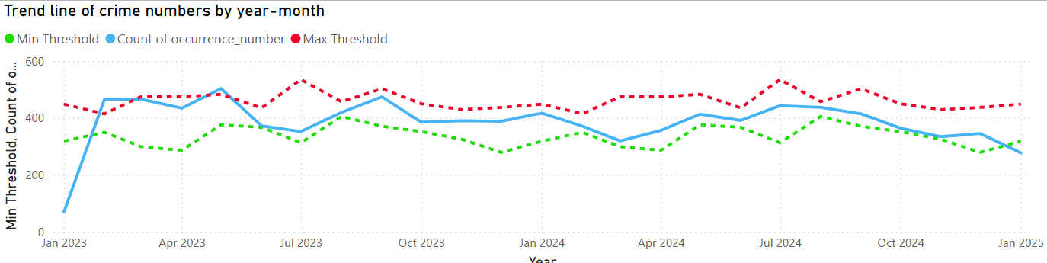

Having said that I feel that we continue have an issue with crime in the more rural wards. The statistics don’t show a notable increase, but I am aware that we continue to have teams from other force areas targeting the Selby District for residential burglaries where vehicles are targeted. A common method seen is where offenders use a blow torch on a uPVC door to gain access via an exposed locking system – we have seen that those addresses where extra attention to crime prevention has been given reap the rewards of not being entered.

We continue to have extra resources in these areas in the hours of darkness and we do have a dedicated investigative and intelligence gathering resource that are regularly in the district doing what they do. This is a most unwelcome trend that we are trying hard to prevent and deter.

Other rural crime continues where fuel / oil is being taken from both residential addresses and HGV’s parked on the road side. Asking your community members to be vigilant is as relevant today as it ever has been.

ASB for the Selby District is also looking positive as the chart below shows. Except for November there has been a steady decrease since June last year. We currently have no significant hotspots for ASB within the District.

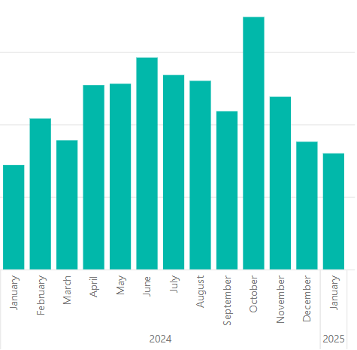

The hidden demand continues to centre around drugs use and supply. My team discovered another potential County Line from Manchester at an address in Selby Town; we have not heard from him or his associates since, but we will continue to remain active with our intelligence gathering abilities. There is a lot of work ongoing in this field.

If you need any of the above data breaking down for the wards you represent, we can easily provide that – please speak to your local officers.

**Kind Regards.**

**Inspector Martin Wedgwood.**

**Contact details.**

* Nicholas Woods - Tadcaster Police Constable

Email: [nicholas.woods@northyorkshire.police.uk](mailto:nicholas.woods@northyorkshire.police.uk)

* Inspector Martin Wedgwood - Selby District Inspector

[martin.wedgwood@northyorkshire.police.uk](mailto:martin.wedgwood@northyorkshire.police.uk)

To ring the police phone 101 for non-emergencies and 999 if there is an immediate risk.

You can also report incidents on line at our website.